Git hub guide website:

Click on the cat in the top left of the screen:



Click on the repository:



Click add file:



Click upload files:  
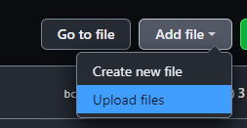

Drag them into the repository:  


Give your upload a name using the following naming convention and add a description in the box:

StudentNumber_Name_Mainchange so for example:A0031189_TobyCotton_KartPhysics

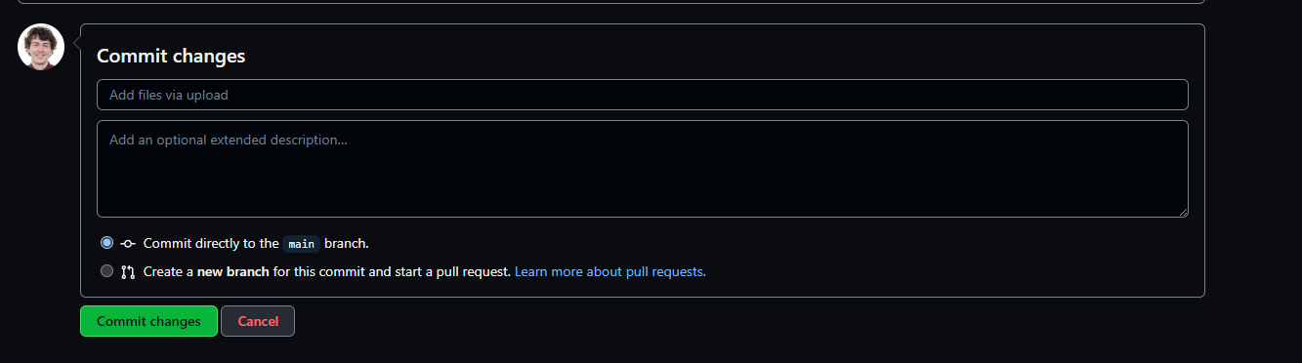

Add the files as a branch then click propose changes:

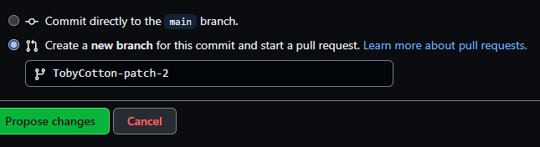

Click create pull request:

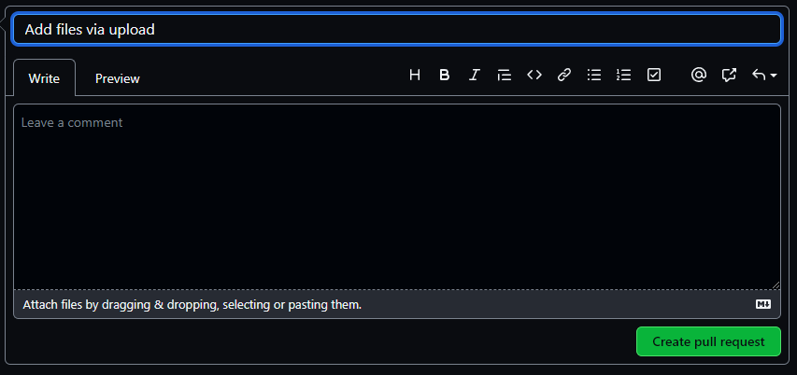

If it says there are no conflicts click merge pull requests:



Else ping a programmer to have a look at the project to check functionality.